BIOLOGY
PAPER I marking key
1 a. Define the term “Sampling”
The technique or method of obtaining a representative sample. (1mark)
b. Figure 1 below shows the tool for sampling. Use it to answer questions that follow.

(i). Identify the tool used for sampling.
Quadrat (1mark)
(ii). Explain any two limitations of using the tool shown above.
Can only be used to sample small organisms / cannot be used to sample large organisms such as elephants or big trees.
Cannot be used to sample moving animals
Cannot be used in steep slope areas (2marks)
c. A form three student wanted to find out the estimated number of chambo fish in a shallow pond using capture –mark-recapture technique. He caught 50 chambos marked them with a white paint on the tail fins and then release them back into the same pond. After 3 days, he made a catch of 50 chambos from the same pond and out of them these, 5 had white paint mark. Use the information to answer the questions that follow.
(i). Calculate the estimated population of chambo fish in the pond
FCM *SC/SCM (1mark)
50*50/5 (1 mark) =500 fish in the pond (1mark)

(3marks)

(ii) Suggest another method that could have been used to determine the population of chambo fish in the same pond.
Direct counting (1mark)
(iii) Explain why he left the marked fish in a pond for three days.
So that the marked fish mix randomly and evenly with the unmarked fish (2marks)
2a. In an ecosystem, a student split a log of dead wood and she found 1000 termites feeding on it. Soon after she had left, two birds came to pick the termites. Use this information to answer the questions that follow.
(i). Draw a well labeled pyramid of numbers to represent this information
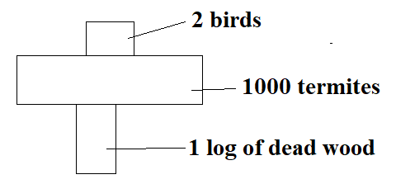 (3marks)
(ii). Why does the pyramid in 2 (a i) have such a shape?
It is because there is only one producer, 1000 termites and 2 birds thus inverted shape (2marks)
b. Describe how a pyramid of biomass is constructed
By using the dry weight /mass of organisms in each trophic level (2marks)
3 a. Define the following processes that take place in water cycle.
- Precipitation
This is whereby the condensed water is released to fall back to the earth in form of rainfall (1mark)
- Infiltration
This is the going down of rainfall water into the ground (1mark)
b. Explain any one point how the following physical factors affect ecosystem.
(i) Soil. Fertile soils more food is made hence more living organisms (2marks)
(ii).Temperature. Organisms are many where temperatures are moderate since enzymes in the body are more active than under low or hot conditions. (2marks)
c. Explain any two ways of controlling air pollution.
- Planting trees. Use up carbon dioxide for photosynthesis hence reducing its level in the atmosphere.
- Use non fossil energy like biogas which do not emit harmful gases into atmosphere (4 marks)
d.(i). Define the term Xerophyte”.
Plants that grow in dry ecosystems. (1mark)
(ii). Give any two examples of xerophyte plants. Aloe, cactus, sisal, (2marks)
4a.What is non-biodegradable wastes? Wastes which cannot rot or decompose such as plastic containers, scrap metals. (1mark)
b. Explain how non-biodegradables can help to spread diseases such as malaria. Plastic containers hold dirty water which provide breeding area for mosquitoes hence help to spread malaria (2marks)
- Figure 2 below shows a transverse section of the leaf. Use it to answer questions that follow.
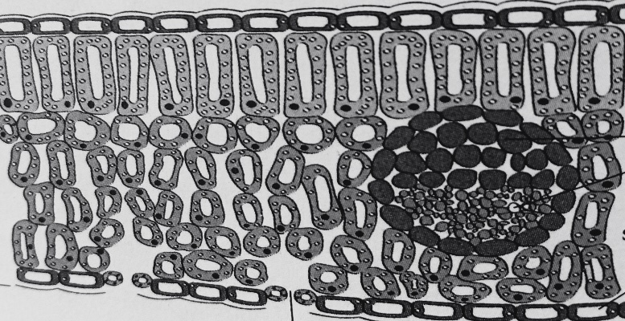
- Identify the parts labeled. (i) X – stoma (ii) Y- Lower epidermis (2marks)
- What a collective name is given to part labeled W. -Vascular bundle (1mark)
- Write down two structural differences you have observed between palisade mesophyll and spongy mesophyll
Palisade mesophyll contains a lot of chloroplasts while spongy few, palisade cells are packed together while spongy cells have airspaces, palisade cell are cylindrical shaped while spongy cells are irregular (2marks)
- (i).What would happen to the rate of photosynthesis if the intercellular air spaces in spongy mesophyll were reduced?
The rate photosynthesis would be reduced (1mark)
(ii). Give a reason for your answer. This will reduce the amount of carbon dioxide gas which is needed for the process (2marks)

- Explain any two adaptations of a leaf for photosynthesis.
It is green in colour which absorb light energy for the process
The surface is broad exposing the leaf to sunlight
Thin blades which reduces distance across which carbon dioxide diffuses from the stomates
Network of veins for transporting food, water and mineral salts
Has transparent cuticle to allow light to penetrate into leaf cells (4marks)
- Figure 3 below is an example of human activities that affect the environment. Use it to answer the questions that follow.

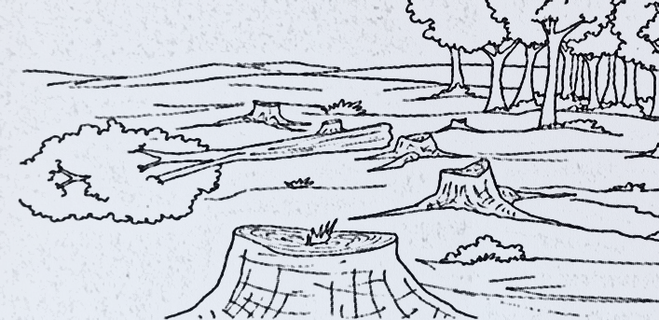
- Identify the activity. Deforestation (1mark)
- List any two impacts the activity has on the environment.
Accumulation of carbon dioxide, soil erosion, drought, extinction of some organisms, desertification, global warming (2marks)
- Describe any two ways of mitigating climate change.
Reforestation –planting trees in areas that once had trees to create carbon sinks
Use of renewable energy such as solar or wind power since they do not produce greenhouse gases
Use of improved crop varieties which grow and mature under unfavorable rainfall patterns (4marks)
- Give any two ways in which Lake Malawi is polluted.
Releasing of organic wastes such as human faeces and sewage
Industrial wastes
Agriculture practices
Oil spills
Detergents from washing in homes and hospitals (3marks)
- Explain any one function of the following mineral elements
- Nitrogen
It is combined with glucose to form amino acids
It is a component of chlorophyll
Component of nucleic acids (2marks)
- Potassium.
Regulates water absorption
Activates enzymes that speed up chemical reactions such as photosynthesis (2marks)
- a. Explain the functions of the following organelles of a plant cell.
(i)Cell membrane. Regulates the movement of materials in and out of the cell /
It holds or encloses the contents of the cell. (2marks)
(ii)Mitochondria
Produce energy for the cell which is used for various activities (2marks)
- Define the term photolysis. The splitting of water molecules into hydrogen ions and oxygen. (1mark)
- What is the main product of photosynthesis? Glucose (1mark)
- Explain any two differences between light stage and dark stage of photosynthesis
Light stage takes place in the grana while dark stage takes place in the stroma
Light stage involves the splitting of water molecules while dark stage involves formation of glucose
Light stage uses light energy while dark stage uses energy ATP stored during light stage. (4marks)

SECTION B
- Expain any five adaptations of goats to their habitat.
- Have hooves with soft spongy inner pad (1) which enables goats to climb high cliffs with greater speed (1).
- Have rectangular pupil in their eyes instead of round(1) that enables them to have excellent night vision.(1)
- The hind legs are heavily muscular(1) to assist in jumping of great distances(1)
- Their teeth are able to regrow after being worn out during feeding
- They have four chambered stomachs with a large rumen(1) for digestion of fibres in plant materials they feed on(1)
- They are browsers hence can get food from both twigs and shrubs(1) hence not to rely on grass alone(1) (10marks)
10. Explain any five fate of glucose after photosynthesis.
- Respiration (1). Plant cells use it to release energy(1)
- Storage.(1) Most of it which is produced in the leaf is usually converted to starch (1)
- Formation of cellulose(1) which is used in making cell walls(1)
- Converted into lipids(1)which is stored in plant tissues like the seed endosperm(1)
- Formation of proteins(1) if combined with nitrates (1) (10marks)
11. Discuss any five effects of air pollution to the environment.
- Causes acid rain(1) which contains large amounts of oxides of sulphur and nitrogen that damages plants, kills fish together with their eggs(1) / causes the corrosions of buildings made from limestone(1).
- Affects breathing in the respiratory system(1) when polluted air is inhaled by human beings and other organisms (1)
- It causes greenhouse effects(1). High concentration of carbon dioxide in the atmosphere traps the layer of heat that could be reflected back into the outer space thereby causing global warming(1)
- Depletion of ozone layer(1).Ozone is a gas which is has three oxygen atoms filters out harmful radioactive rays that are destructive to life on earth(1)
- Photochemical smog(1)which is a mixture of air pollutants that destroys chlorophyll in plants,injures lung tissues and causes irritation in the eyes in humans(1).
- Causes respiratory diseases such as emphysema and bronchitis(1).Emphysema is a condition in which the alveoli are weakened and made elastic causing long term irritation of the lungs(1)./Bronchitis which is caused by cigarette smoke and air pollutants makes one to secrete excess mucus as a result of irritation of the respiratory system(1).
(10marks)

